THE ECONOMETRIC MODEL (MULTIVARIATE MODEL)

 Statistically speaking, multivariate analysis refers to statistical models that have 2 or more dependent or outcome variables, Van Belle G. *Biostatistics: A Methodology for the Health Sciences*. Hoboken, NJ: Wiley-Interscience; 2004 [[Google Scholar](https://scholar.google.com/scholar_lookup?title=Biostatistics:+A+Methodology+for+the+Health+Sciences&author=G+Van+Belle&publication_year=2004&)] [[Ref list](https://www.ncbi.nlm.nih.gov/pmc/articles/PMC3518362/#bib1)] and multivariable analysis refers to statistical models in which there are multiple independent or response variables.  Katz MH. Multivariable analysis: a primer for readers of medical research. *Ann Intern Med*. 2003;138(8):644–650 [[PubMed](https://pubmed.ncbi.nlm.nih.gov/12693887)] [[Google Scholar](https://scholar.google.com/scholar_lookup?journal=Ann+Intern+Med&title=Multivariable+analysis:+a+primer+for+readers+of+medical+research&author=MH+Katz&volume=138&issue=8&publication_year=2003&pages=644-650&pmid=12693887&)] [[Ref list](https://www.ncbi.nlm.nih.gov/pmc/articles/PMC3518362/#bib2)]

A multivariable model can be thought of as a model in which multiple variables are found on the right side of the model equation. This type of statistical model can be used to attempt to assess the relationship between a number of variables; one can assess independent relationships while adjusting for potential confounders.

A simple linear regression model has a continuous outcome and one predictor, whereas a multiple or multivariable linear regression model has a continuous outcome and multiple predictors (continuous or categorical). A simple linear regression model would have the form



By contrast, a multivariable or multiple linear regression model would take the form



where y is a continuous dependent variable, x is a single predictor in the simple regression model, and x1, x2, …, xk are the predictors in the multivariable model.

As is the case with linear models, logistic and proportional hazards regression models can be simple or multivariable. Each of these model structures has a single outcome variable and 1 or more independent or predictor variables.

Ref: (<https://www.ncbi.nlm.nih.gov/pmc/articles/PMC3518362/#:~:text=Statistically%20speaking%2C%20multivariate%20analysis%20refers,independent%20or%20response%20variables.2>)

In this Study we had multiple variables hence an econometric model which accounts for all these variables had to be used which would tell us the relationship between all variables using the R adjusted R^2 and root mean square (RMSE).

The Multivariate Analysis of Variance (MANOVA)

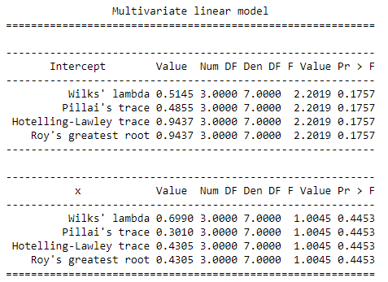

##### The multivariate analysis of variance (MANOVA) was used to test the significance of the regression model as pertains to significance in the differences in the means of the dependent and independent variables. The MANOVA test produced a p-value of 0.4453, f-value= 1.0045 signifying that there is no significant relationship between the independent and dependent variables. From the result the researcher therefore accepts the null hypothesis and conclude that there is no linear relationship between Exchange Rate in LCU per USD, 'FDI Inflows in Zimbabwe (In USD)', *Trade openness (as a percentage)* and 'GDP (in USD)'. It also shows that the independent variable cannot predict the dependent variables with a certain higher degree of accuracy. The significance level being below our threshold of 0.05 confirms that the significance of Exchange Rate in LCU per USD to 'FDI Inflows in Zimbabwe is lower and confirmed by the F test.

**Model Summary and Interpretation**

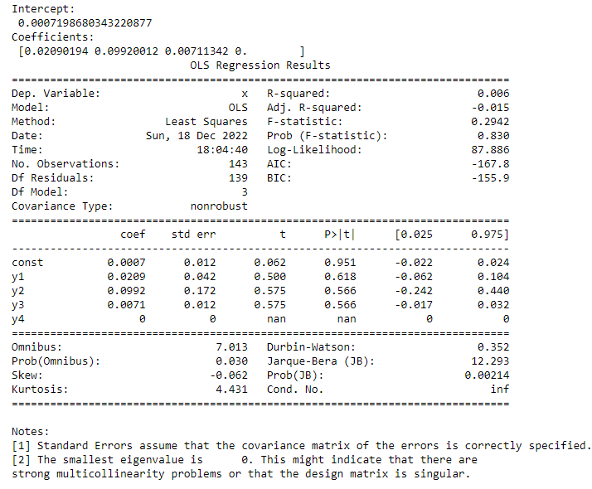

The study indicates that the Exchange Rate in LCU per USD has no significant impact on 'FDI Inflows in Zimbabwe’. From the T- test at 95% level of significance, there is no relationship between Exchange Rate in LCU per USD, 'FDI Inflows in Zimbabwe (In USD)', *Trade openness (as a percentage)* and *GDP (in USD)* '. However, the model is summarised below which can be used even though the model is not that much accurate.

Using the multiple linear Regression Model

Y = B0 + B1X1 + B2X2 + B3X3+ error

the Equilibrium Model will be

Y(t) = 0.00072 + 0.0209X1(t) + 0.0992X2(t) + 0.0071X3(t) +0X4(t) + error terms

hence given the ‘Exchange Rate in LCU per USD', *GDP (in USD)* and *Trade openness (as a percentage)* we can estimate 'FDI Inflows in Zimbabwe (In USD)'.

However, this model has to be used with caution as it is of lower accuracy hence wrong predictions might be predicted.

Therefore, the final econometric model in laymen’s terms will be

*FDI inflows in Zimbabwe (In USD)* = 0.00072 - 0.0209Exchange Rate in LCU per USD + 0.0992 *GDP (in USD)* + 0.0071*Trade openness (as a percentage)* + error terms

A unit increase in Exchange Rate in LCU per USD would reduce by *GDP (in USD)* hence *FDI inflows in Zimbabwe (In USD)* would almost remain unchanged hence Exchange Rate does not influence The FDI inflows.

**CHAPTER FIVE**

**SUMMARY, CONCLUSION AND RECOMMENDATION**

**5.1 Introduction**

This chapter concludes the results of the study by giving the summary of the study. Summary of the findings, what the research has concluded, policy recommendations, limitations of the study and suggestions for further research are discussed in this chapter.

**Summary**

The objective of this study was to establish the relationship between Zimbabwe’s exchange rate and Foreign Direct Investment. In addressing this relationship, a research question was postulated as to whether exchange rate impact Foreign Direct Investment? From Fig above, F R adjusted is 0.343 which is very low which indicates that the model is not a good fit thus it shows that the model is a weak predictor of the outcome, since it is below the threshold of 0.05. Thus, there is no relationship which exists between the dependent and independent variables for the study implies no direct and related link between the two variables. Hence exchange rate should not be used alone to predict the Expected FDI since it is a poor estimator for the FDI, hence other variables have to be used to study the Foreign Direct Investment.

**Conclusion**

The research was carried out using secondary data. The research’s main aim was to evaluate the impact of Zimbabwe’s exchange rate on Foreign Direct Investment; to determine whether the exchange rate in Zimbabwe impacted on economic growth since FDI greatly affects economic growth of developing countries; and to establish measures which can be adopted to ensure that exchange rate does not hinder Country growth. The study found that exchange rate has no impact on FDI. If high exchange rates are set, the FDI will not be affected thereby no economic growth nor reduction FDI will remain the same. This is undesirable to the investor, Since This Variable is hugely expected by the investors to cause some fluctuations in the FDI now the investors won’t be certain of what the FDI would be like since it can’t be predicted by the exchange rate hence other variables which won’t be easy to track might affect the FDI. There are other factors that also influence FDI such that, even if exchange rate is reformed in Zimbabwe, FDI will still find it hard to Be predicted in Zimbabwe. The hypothesis of this study which had stated that exchange rate has no impact on FDI couldn’t be rejected.

**Policy Recommendation**

Investors all around the world trade huge sums of foreign currency every day. It's these trades that determine the exchange rates for the pound. These rates are the basis for the rates you get in banks and foreign exchanges when you change money from one currency to another. Hence exchange rates are generally determined by the market forces of supply and demand for foreign exchange.

Since this study showed that exchange rate does not affect FDI hence other variables have to be studied to check if they might affect the FDI, however in this study there are no any recommendations that can be accelerated since FDI won’t be affected by the exchange rate.

Hence For other Researchers in who might want to investigate On the Variables which affect the FDI would have to research using other variables.